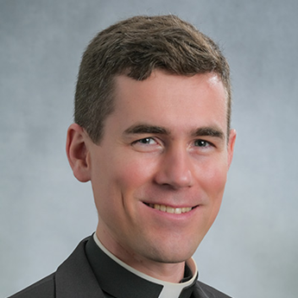
Fr. Peter Ascik
Pastor, St. Mary Help of Christians, Shelby, North Carolina
Father Ascik is currently the pastor of St. Mary, Help of Christians Parish in Shelby, North Carolina, and its mission church in Kings Mountain. He was officially installed as pastor in August 2024 after serving as a parochial vicar at St. Matthew Church in Charlotte for three years. Father Ascik emphasizes faith formation, youth ministry, and building fellowship in his parish community, while striving to connect the parish with the wider local community through outreach and charitable efforts
He also serves as the pastor and rector of The Cathedral of Saint Patrick in Charlotte, North Carolina.
Father Ascik was the first director of the new Diocese of Charlotte Office of Family Life, a role that highlights his special devotion to family and pro-life ministry. Raised in a family of nine children near Asheville, he was ordained in 2017 and has pursued advanced studies in moral theology with a thesis on marriage. In this role, he oversaw marriage preparation, pro-life ministry, natural family planning, elder ministry, and diocesan family events
Father Ascik is a vocal pro-life leader, involved in the "Walking with Moms in Need" initiative within the Diocese of Charlotte. This parish-based ministry supports pregnant and parenting mothers by building networks of social services and material resources. He promotes "radical solidarity," encouraging the Church community to provide ongoing personal and practical support to vulnerable women, reflecting a holistic approach to pro-life advocacy beyond legal concerns
Father Ascik studied at the Pontifical North American College in Rome and is the son of Thomas and Karen Ascik. He was ordained in 2017 and has served in various parish roles, with interests including literature, philosophy, and science. He values preaching, celebrating sacraments, and guiding people to experience the closeness of God.

